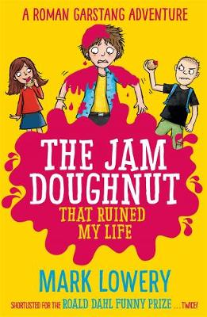
The Jam Doughnut That Ruined My Life by Mark Lowery
Because of his Monday-morning jam doughnut, Roman's week takes a very sticky turn...
By Friday Roman has been banned from eating for 24hrs, narrowly avoided a faceful of warm toddler-wee, accidentally shoplifted, been given a lift in a getaway van, styled his teacher's guinea pig with a blue Mohawk, started an OAP riot ...and still barely managed to scoff a crumb - or lick - of a single doughnut. Who knew jam could be so deadly?

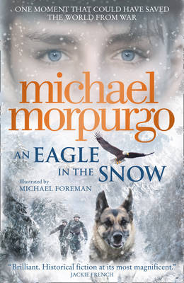
An Eagle in the Snow by Michael Morpurgo
The powerful new novel from the master storyteller - inspired by the true story of one man who might have stopped World War II, it bears all the hallmarks of the next Morpurgo classic and is another stunning and resonant story of war and its impact on ordinary people.
The train is under attacks from German fighters. In the darkness, sheltering in a railway tunnel, the stranger in the carriage with Barney and his mother tells them a story to pass the time. And what a story. The story of a young man, a young soldier in the trenches of World War I who, on the spur of the moment, had done what he thought was the right thing. It turned out to have been the worst mistake he ever could have made - a mistake he must put right before it is too late...

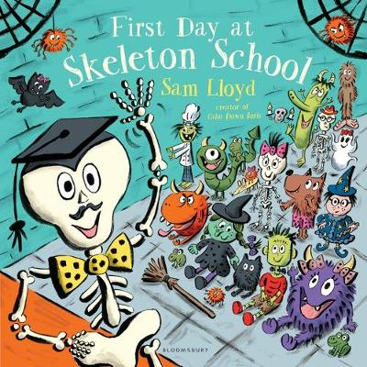
First Day at Skeleton School by Sam Lloyd
Listen ...can you hear it? There's a creepy noise ...'Welcome!' smiles Mr Bones. 'Meet the spooky girls and boys.' At Skeleton School they howl in assembly, fly broomsticks in the library and learn how to float through walls! Join in the fun with this comic caper from a bestselling author/illustrator of Calm Down, Boris, Mr Pusskins and First Day at Bug School - it's perfect for back to school and Halloween.

